Homework 2
- All homework must be turned in on PDF format. This can be scanned or typed in any paper size, but the format must be PDF and the file must be readable. This document can be modified for your homework submission. An additional homework template is available on Canvas to assist you in creating your answers, and content from lecture notes can be used.
- All final answers must be circled or in green.
- All homework must have a name on the top of every page.
- Submission errors (not in PDF, illegible, etc.) will not be re-graded.

Problem 1
Convert the following decimal (base-10) numbers into binary (base-2). Results should be accurate to within ${0.01}_{10}$.
- Convert $-{121.625}_{10}$ into hexadecimal.
- Convert $-{121}_{7}$ into hexadecimal (hint: go through base 10). Problem 2

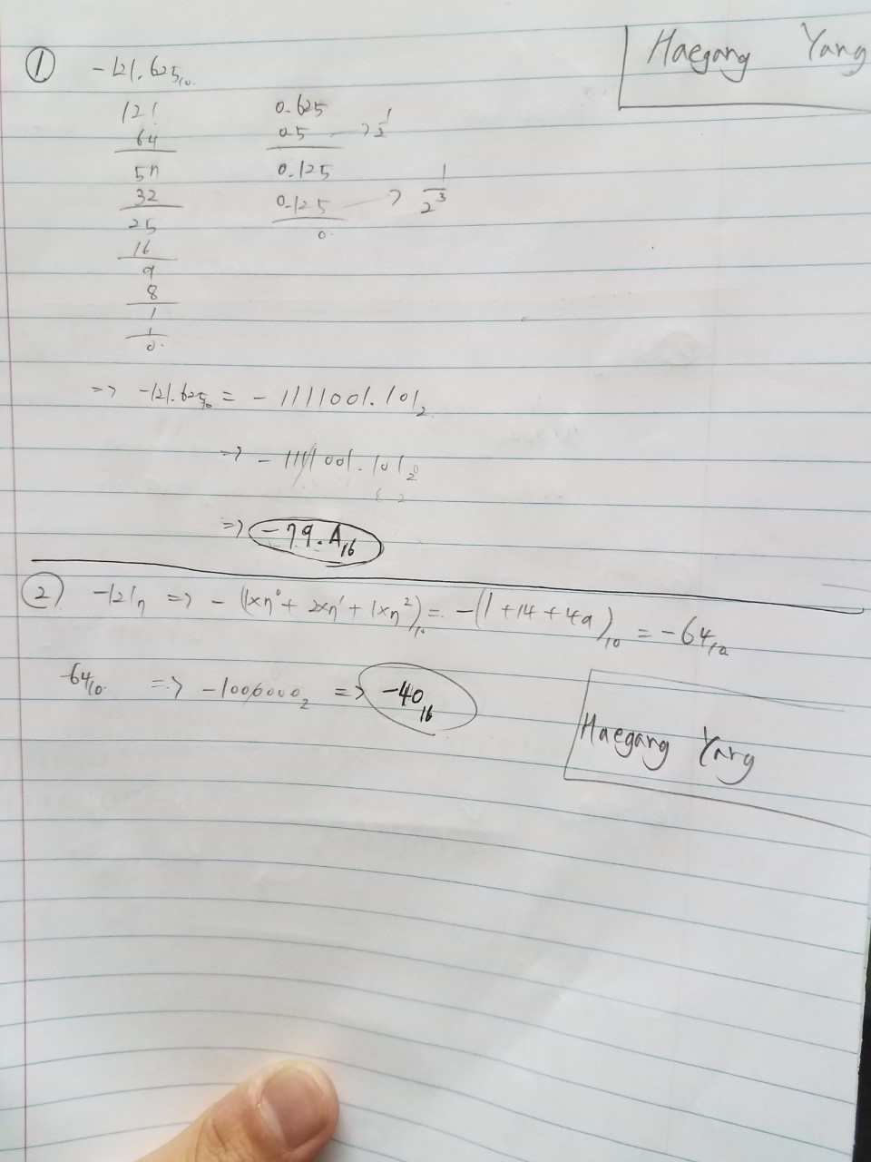
Perform the following arithmetic problems.
- ${143}_{7}+{153}_{7}$ (perform the operation and express your answer in base-7).
- $1AE_{16}-2F3_{16}$ (perform the operation and express your answer in base-16).
- ${10110111}_{2}×{10010001}_{2}$ (perform the operation and express your answer in base-2).

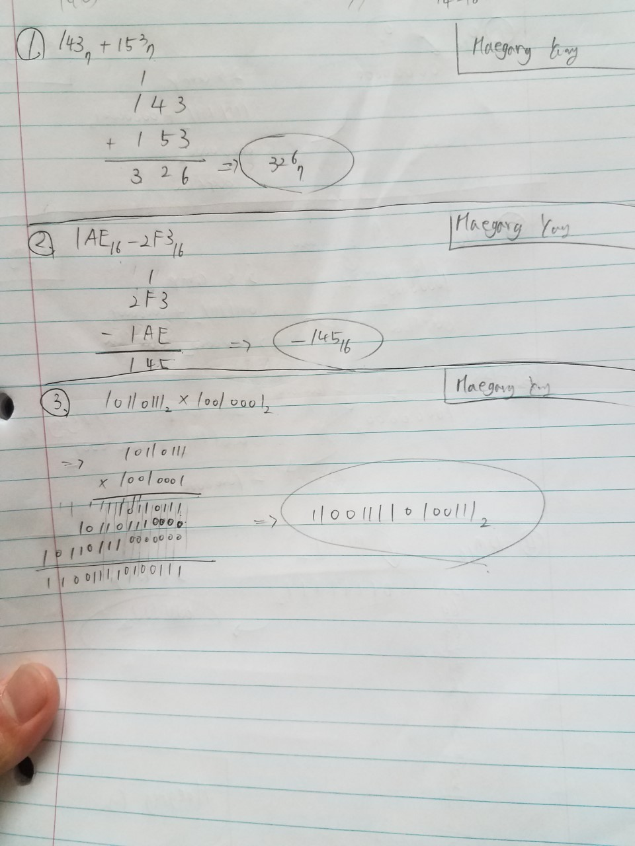

Problem 3
Give the base-2, 8-bit signed magnitude, and 8-bit 2’s complement representation of the following numbers. Note any irregularities in your answer and work.
- $0_{10}$
- ${128}_{10}$
- $-{128}_{10}$
- ${127}_{10}$
- $-{127}_{10}$
- $-{52}_{10}$

